Report

Team16

1.Explanation of the python script to get weather information：

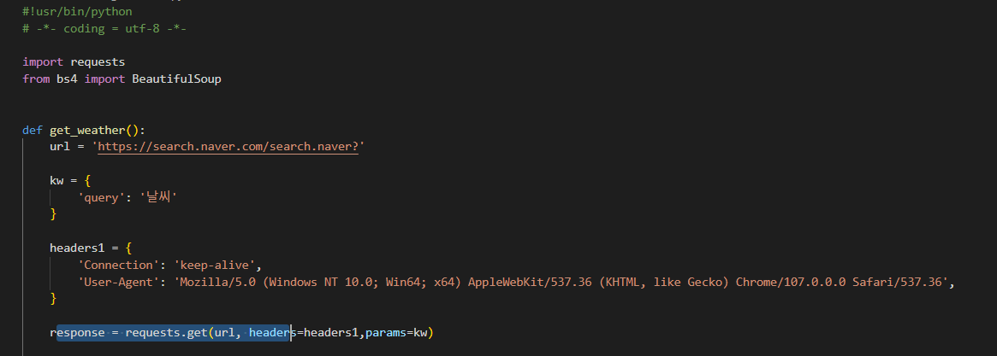

Get web content information through the requests library

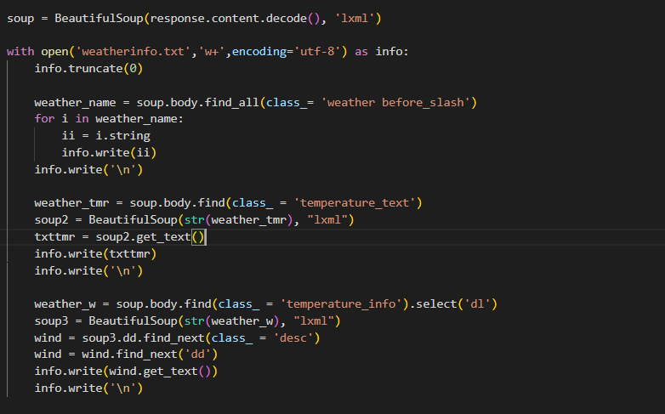

The web pages are parsed by calling the beautifulsoup4 library, while the web interpreter used is lxml. After that, we created a txt file named weatherinfo to save the obtained data. We use the beautifulsoup4 library's find() and find_all() functions to retrieve keywords and find the content we need. Then write it to the txt file.

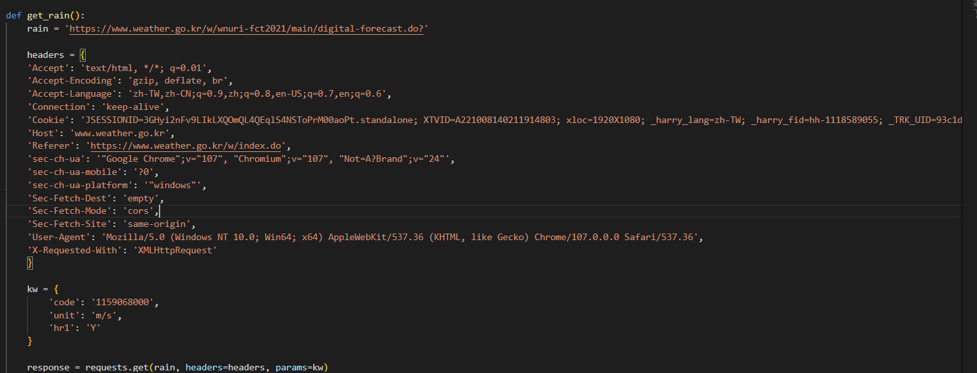

At the very beginning, we chose to get the data by crawling the official website of the Meteorological Department. However, during the crawling process we found that the website used asynchronous technology, which made it impossible for us to crawl it properly. In order to get the relevant content, we obtained the js used in the web page by grabbing the packets and successfully crawled the information by sending a separate request for the source code of this part of the web page. The figure shows the request headers and overloaded keywords used to crawl the information. The value of the 'code' attribute in 'kw' determines whether we can crawl that part of the page or not.

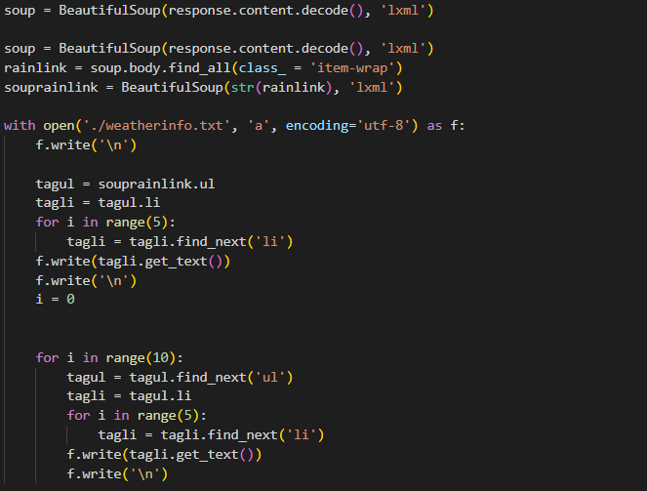

Agree that it is parsed by beautifulsoup4 library and the web interpreter is lxml. find the content we need. Then write it to the txt file.

2.Explanation of the main body and ui part of the program：

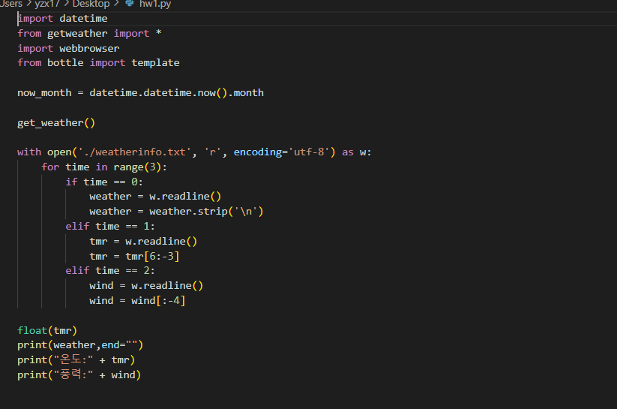

Call the python program written to get the weather information and store the obtained information in a variable

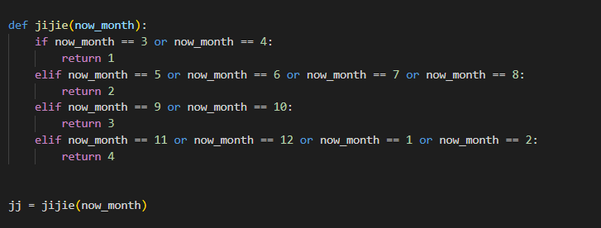

Determine the season and store the result in a variable for later use

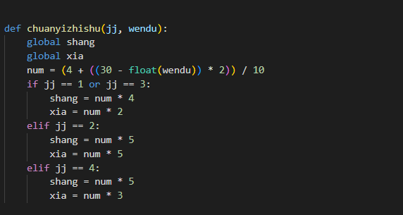

Pass the temperature and season into the function, and get a num value by 4 + (30 - now get the temperature) * 2/10, and subsequently will use the num value to determine what kind of clothes to wear

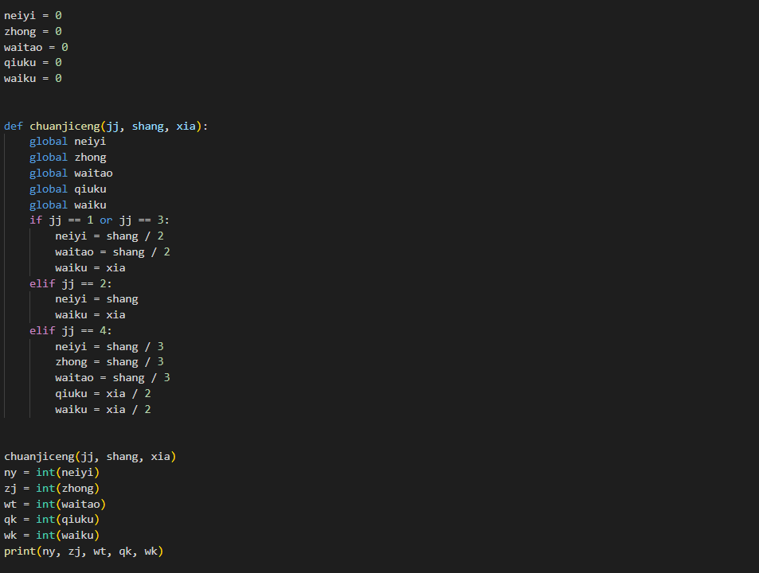

Determine how many layers of what kind of clothes and how many layers of what kind of pants you need to wear by season and num value and convert the calculated value to an int variable and store it in the parameter for the next

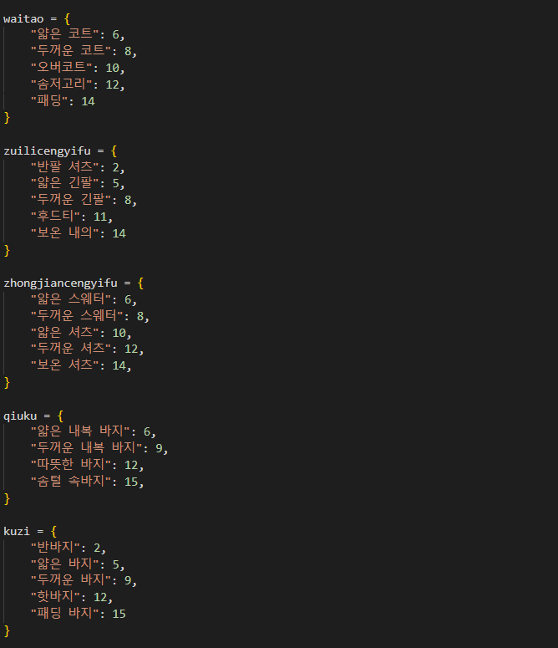

Use library to write a library of clothes value is the type of clothes key is the different warmth values corresponding to different clothes

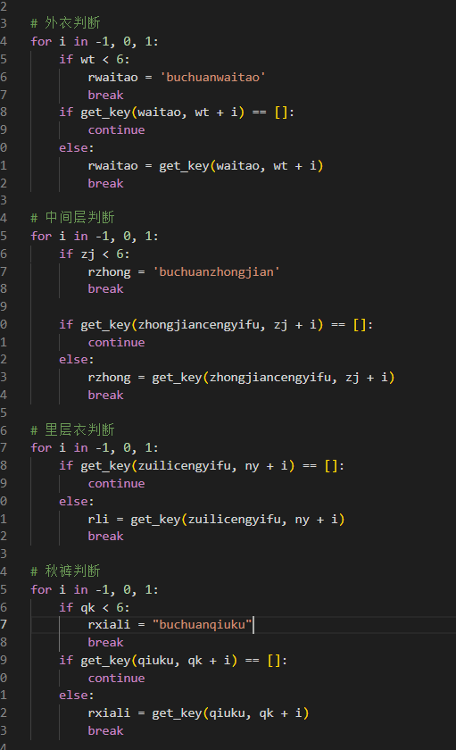

Pass the calculated dress index of each layer into the function to find the corresponding clothes by key in the library and recommend them to the user

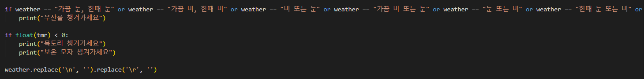

Rain reminds to bring umbrella, snow reminds to wear scarf and hat

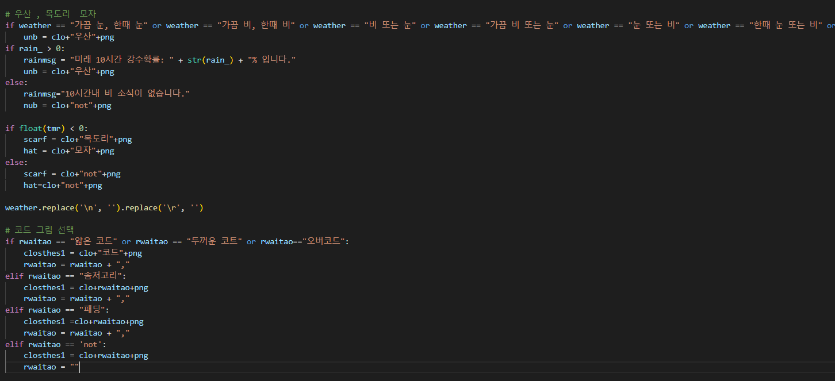

Prompt users to bring umbrellas and scarves according to the weather and temperature

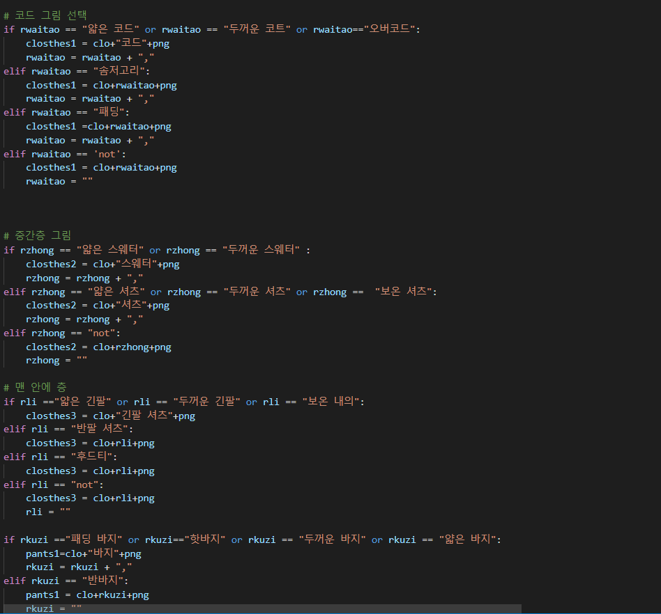

After getting the current recommended clothes according to the upper layer program, the returned clothes name is judged and modified to the path name of the corresponding picture of the clothes

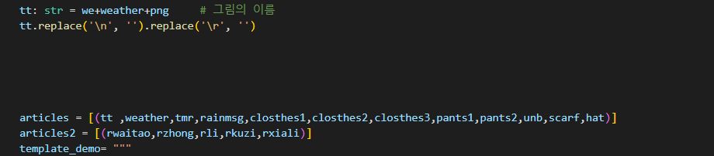

The variables that contain the paths to the image names are stored in a list type variable.

Ui소개

We chose to use html to build our ui for presentation to the user

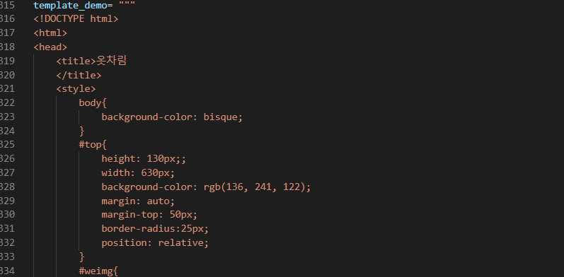

We store the entire html code that we have written into variables in our python program.

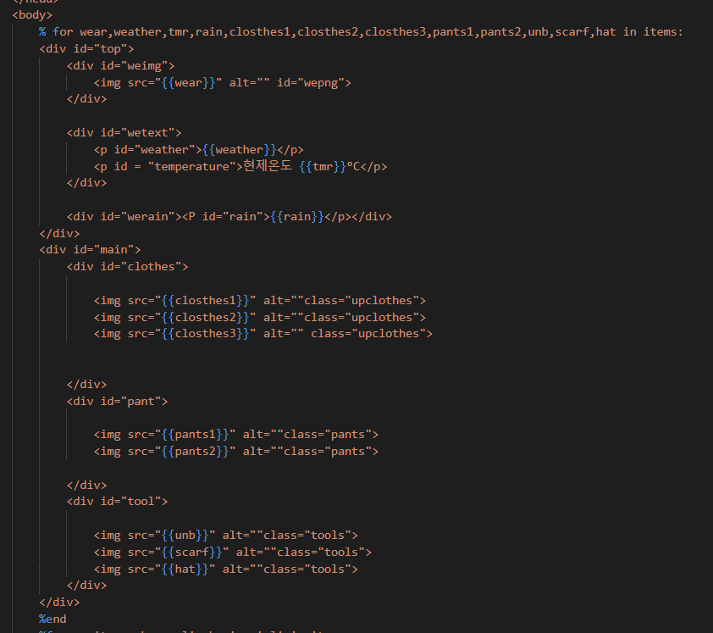

Using python's bottom library, we can pass the variable with the image information into the html tag for our ui display

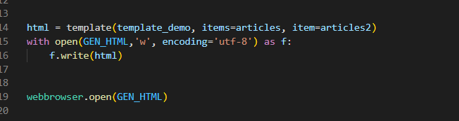

Write all the html code to the variable html using the template method, write the data in the variable html to demo_1.html using the file write method and then open the html with the webbrowser

Above is the code introduction of our program

Finally we package the source code into an executable exe file.

Open it to get the weather information and clothing recommendations for the day directly

역할분당:

왕우박: 1.날사정보 수집 부분의 코드 작성(게인완성) 2.프로그렘 코드 작성3.프로그렘 설계

원복용: 1.중간팔표2.프로그렘 설계3.UI부분 코드 작성4.PPT 착성

요지학: 1.중간 및 기말 보고서랑 발표문 작성2.프로그렘 코드 작성성(주로)3.프로그렘 설4.옷 추천부분 알고리즘 설계5.발표문 작성

와성룡: 1.중간 및 기말 발표2.UI부분 코드 작성3.프로그렘 코드 작성4.옷 추천부분 알고리즘 설계